Math Quiz Solutions

- (17 points) Summations: Give a closed form solution to 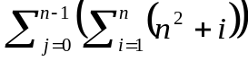 . Your answer should be a polynomial function of n.

SOLUTION:

2. (17 points) Graphs: For this graph, list the vertex labels of the largest strongly connected component.
AA
BA

SOLUTION: A, C, D, E, F
FA
CA

DA
EA

3. (17 points) Trees: Draw all the different binary, rooted trees that can be formed using at least one and at most 3 nodes.
A
A
A
A
A
SOLUTION: 1) 2) 3) 4) 5) 6) 7) 8)
A
A
A
A
A
A
A
A
A
A
A
A
A

A
A
4. (17 points) Probability: If you flip a fair, 3-sided coin three times, what is the probability that at least 2 flips will result in heads? (Assume that the 3 sides are H = heads, T = tails, and M = middle.)
SOLUTION: There are 3³ = 27 possible outcomes. 3 heads: HHH = 1 outcome. 2 heads: HHT, HHM, HTH, HMH, THH, MHH = 6 outcomes. 7 of 27 outcomes have at least 2 heads, so the probability =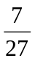.
5. (16 points) Calculus: Evaluate 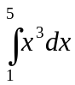.
SOLUTION: 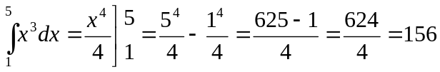.
6. (16 points) Logarithms: TRUE or FALSE: 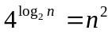.
SOLUTION: TRUE 

